Lab 1: Understanding ORM with a Retail Inventory System
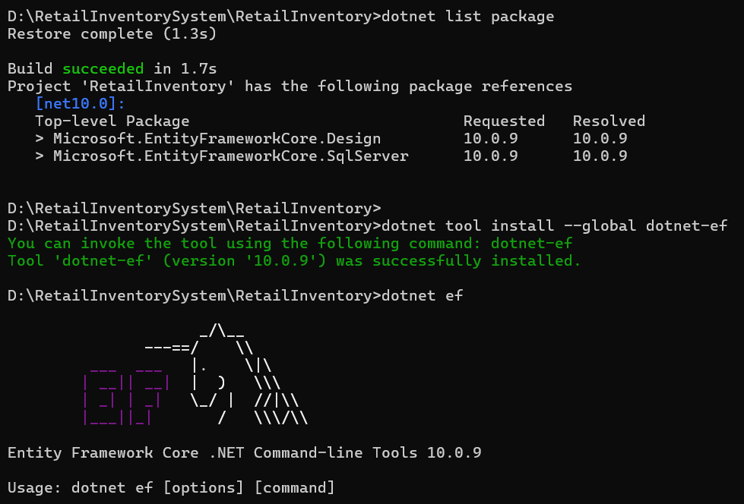

Lab 2: Setting Up the Database Context for a Retail Store
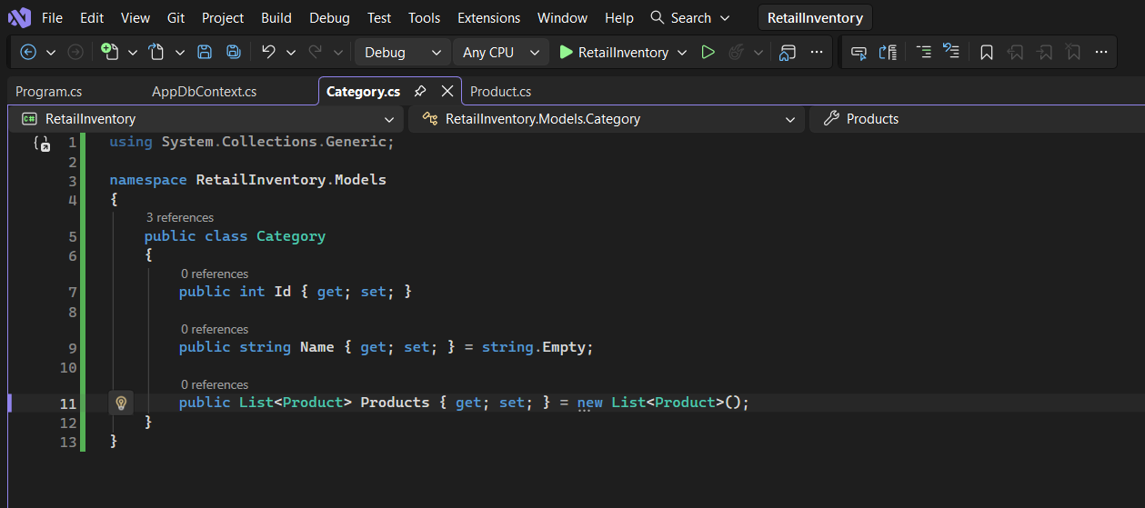
Category.cs:

Product.cs:
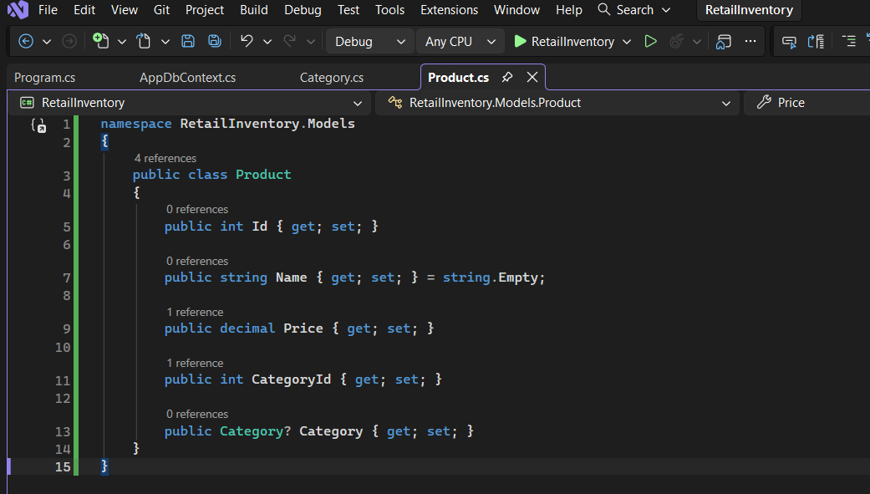

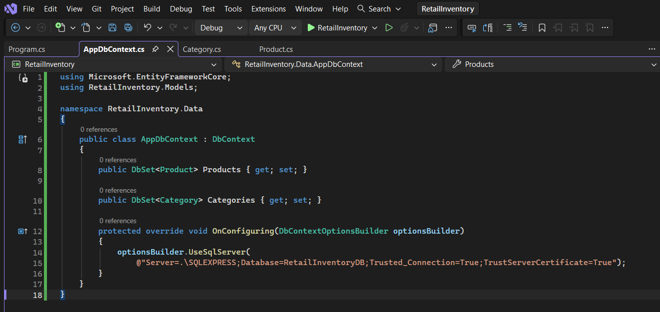
AppDbContext.cs

Lab 3: Using EF Core CLI to Create and Apply Migrations:
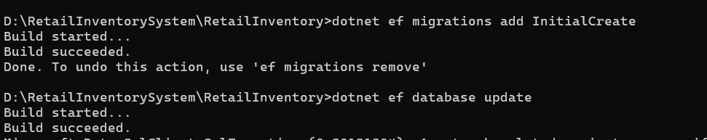
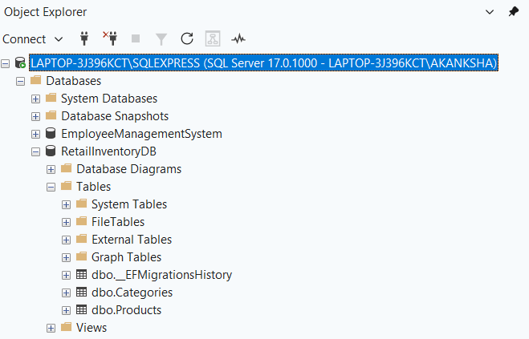
Lab 4: Inserting Initial Data into the Database
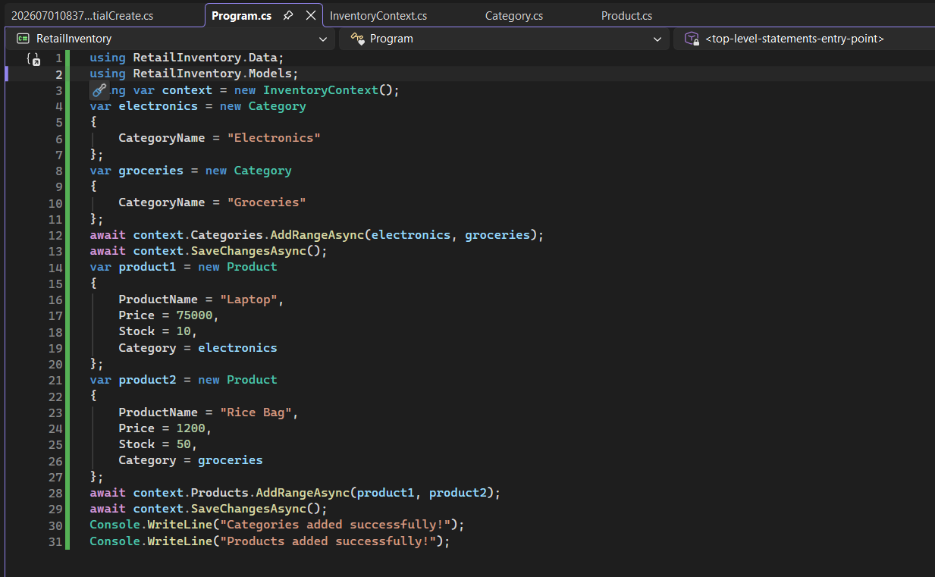
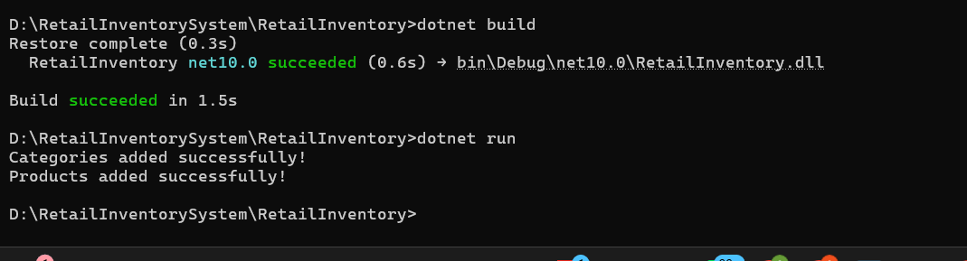

Lab 5: Lab 5: Retrieving Data from the Database
